KYOCHAN3.0_Chiral Instruction

Shusaku ASANO (shusaku_asano@cm.kyushu-u.ac.jp)

# Update note

## 2021/05/24 Ver 3.0 has been published on GitHub.

# About KYOCHAN_Chiral

KYOCHAN_Chiral is a standalone software for automated analysis of stereochemical stability of dynamic chiral molecules using a microflow setup. Its details and benefits are described in a publication DOI:xxxxxxxx.

KYOCHAN_Chiral has limited functions of the KYOCHAN platform, which covers a broad range of lab automation and intelligent flow chemistry. If you have interest in applications not described in DOI:xxxxxxxx, please contact the corresponding author.

## Hardware requirement

### Syringe pump:

Many models of the syringe pumps are supported in KYOCHAN_Chiral. It should have a USB or RS-232 connection port. Pump11 Elite or PHD ULTRA (Harvard Apparatus) is recommended.

### Temperature sensor:

TC-01 (NI) is supported.

### Digital output device:

USB-DAQ (such as USB-6001, NI) and Compact DAQ (such as NI-9482, NI) modules are supported.

### 6 port valve:

Valves controlled by digital input or relay contact can be used. VA-21 series valve (FLOM) is supported exceptionally.

### HPLC system:

Any models of HPLC system which have start signal input can be used.

## Connection setup

### Syringe pump:

Connect PC and pump with USB-B cable or RS-232 cable. Note that the RS-232 cable wiring is dependent on the syringe pump models.

### Temperature sensor:

Insert J or K thermocouple terminal to TC-01. The tip of the thermocouple should be placed at the center of the oil bath.

### Digital output device:

In the case of the USB-6001, MOS relays (such as AQZ-207, Panasonic) should be implemented to convert 5V output lines to the relay contact lines. In the case of relay output devices such as NI-9482, no conversion is needed. Relay contact lines are used for heater control, valve control and HPLC start signal.

### Heater:

The tape heater or mantle heater should be connected as the following schematics.

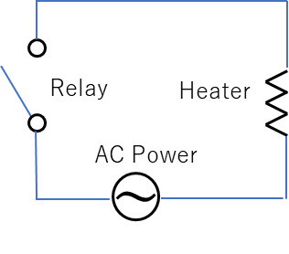

Heater power is controlled with the duty cycle of the relay module. By the combination of the TC-01 temperature input, KYOCHAN_Chiral enables accurate temperature controls up to 200°C. However, it does not provide a safety function to prevent fire accidents. The author does not take any responsibility for the accident during the operation.

### 6 port valve:

In the case of the VA-21 series valve (FLOM), two of the connection terminals can be connected to the relay line of the digital output device.

### HPLC system:

Connect one of the relay lines to the start signal input terminal of the HPLC system. Generally, the start signal input is open or connected to the manual injector. You do not need to remove the manual injector connection. You can insert a new connection cable besides that of the manual injector.

## Software Install

KYOCHAN_Chral requires the NI runtime engines. When you first try to open KYOCHAN3.0_Chiral.exe, your PC will search these runtime engines on the web. These are free and you do not need to have commercial a LabVIEW development license.

# Operation

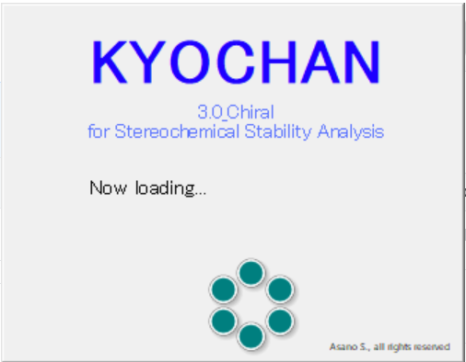When you open the KYOCHAN3.0_Chiral.exe after the installation of runtime engines, you will see the opening message (right) and then, main panel (below).

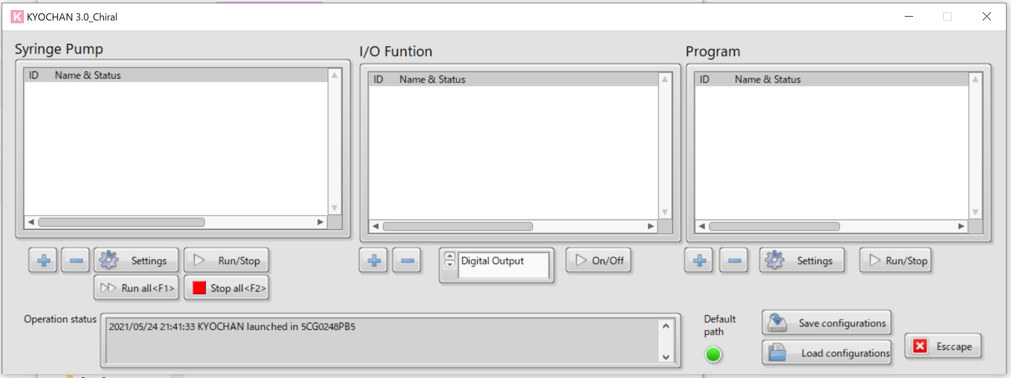

## Syringe pump

### Register

1. 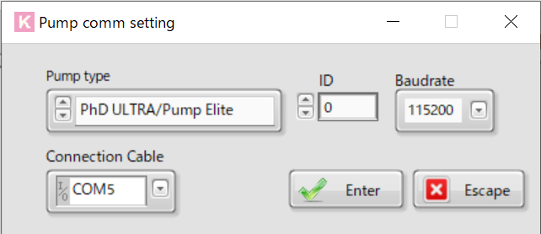Click + button at the right window.
2. Choose pump model, COM Port, and baud rate. If you do not know about these terms, please check the syringe pump manual. ID should be 0. Click <Enter> of the popup window.
3. You will find pump information on the window.

### Setting

1. 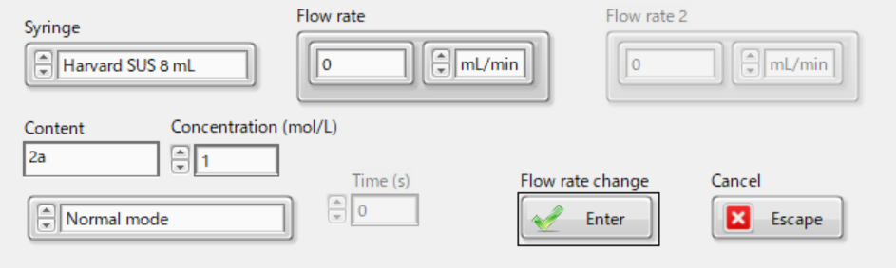Click the Setting button at the right window.
2. Choose your syringe from the list. Content is just for commenting. Do not change from normal mode. Concentration can be either actual value or 1 for convenience but should not be 0. You can change the flow rate for the communication test.
3. Click <Enter>.

### Run/Stop

If you click the Run/Stop button of the right window, your syringe pump will run.

## Other devices and program

Other devices are registered and operated at the center window. To register devices, you need to choose device type in the list tab and then, press + button.

### TC-01

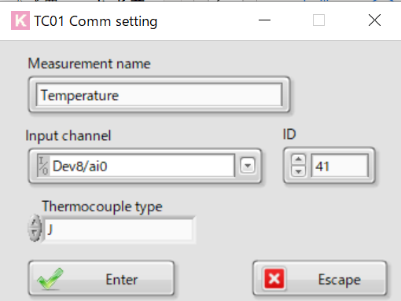Choose “TC-01” at the tab. When you press + button, you will see the popup window. ID should be 41. At the input channel tab, you need to choose your TC-01 device name. When you connect TC-01, a popup window will tell you the device name. After clicking the Enter button, you will see the chart showing the current temperature.

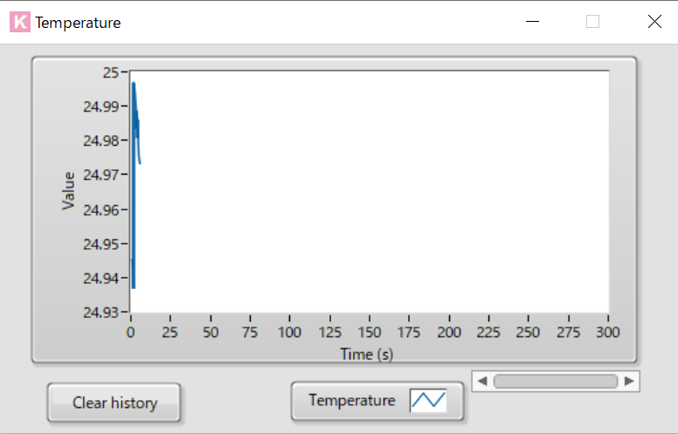

### Heater, valve, and start signal

Choose “Digital Output” at the tab. If you want to use the VA-21 series valve, choose the FLOM valve. You then need to choose an appropriate port number and set ID. Be careful with the port and line number. Channel Name is optional but make sure to enter the description because the misuse of the heater will cause a severe accident. The recommended ID list is below:

Heater: 100, Valve: 101, Start signal: 102.

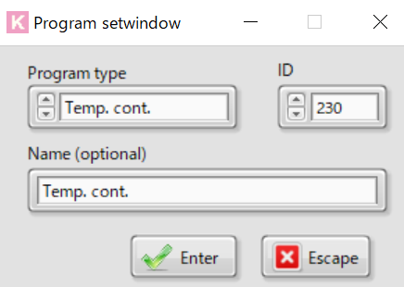After clicking the enter button, the device will be listed on the table. You can manually operate through the On/Off button. It is strongly recommended to test the On/Off functionality of each device before the experiment.

### Temperature control

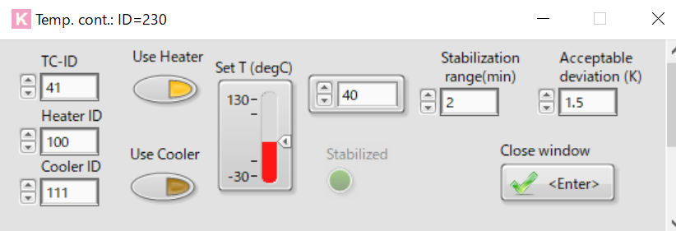Temperature control is achieved by controlling heater with the TC-01 input. To implement the functionality, you need to register temperature controller on the right window. You can register by clicking the + button and choose Temp. Cont. program (left). At the setting window, you need assigning of TC-01 ID (41, recommended) and heater ID (100). After clicking Enter button, temperature controller is ready to run. When you press Run button, heater will start.

### Temperature logging

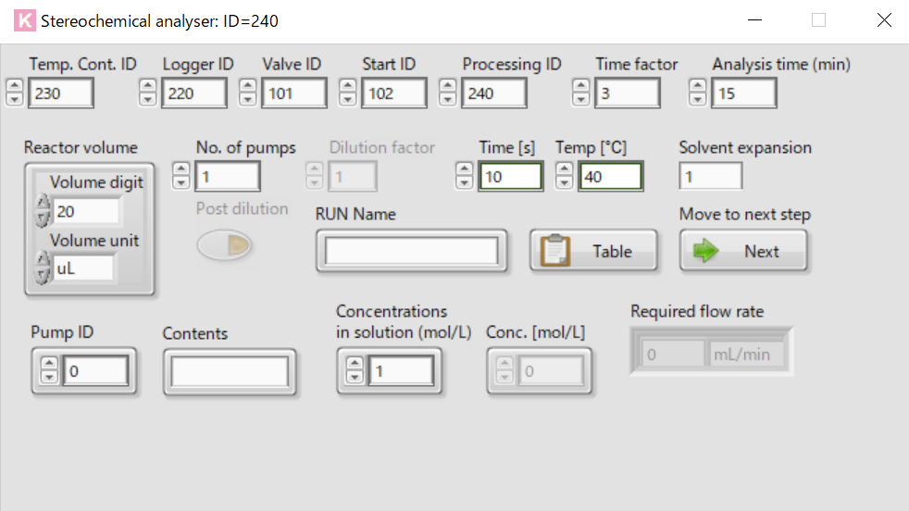Register data logger at the right window. Then, enter TC-01 ID (41) in the setting window. After clicking the <Register channels>, you can start data logging.

## Automated analysis

Register the “Stereochemical analyzer” program at the right window. When you click the setting button, you will see the analyzer window and Table window. Refer the spreadsheet in the <file path> dialog and click <Load>. You can use the excel file template to make a spreadsheet with your measurement conditions. Concentration written in the spreadsheet should be identical to that in the pump setting. Choose appropriate IDs of the pump, logger, valve, start signal, and temperature controller.

KYOCHAN and HPLC synchronize only with the start signal that KYOCHAN generates at the end of the pumping. You need to start up your HPLC system with the native control software (i.e. LabSolutions by Shimadzu, ChromNAV by JASCO). Usually, HPLC control software provides a “batch analysis” function which enables the repetition of start signal waiting and analysis. If you correctly input the HPLC analysis time in KYOCHAN, these two systems work complementary.

After finishing both setup, press Run button at the right window to begin temperature control, logging, pumping, valve rotation, and analysis. Pump flow rate, valve positioning, set temperature automatically change according to the spreadsheet you have made.

